**Digital Transformation: Enhancing IoT**

**-**

**driven Solutions for Smart Islands**

___________________________

Jamal

Sophieh

Expert and

Manager of Digital Economy Department (ICT ministry of Iran)

jsophieh@ut.ac.ir



Applied use cases in the implementing smart islands

–

use case

2



**Jamal Sophieh**

More than 20 years of experience in the ICT sector and in management and business field

PhD of Entrepreneurship and Business Creation (University of Tehran- Entrepreneurship Faculty)

University Instructor and Lecturer in University of Tehran and University of Shahid Beheshti (Tehran) for 5 years.

Senior Instructor of Digital Transformation and Digital Economy



Expert and Manager of Digital Economy Department (ICT ministry of Iran) for 5 years.

Coordinator and Expert of ITU Study Groups (Telecommunication Infrastructure Company- TIC.ir) for 3 years

Senior Analyst of Strategic and Comprehensive Planning (Telecommunication Infrastructure CompanyTIC.ir) for 5 years

Journalist and Analyst of ICT Specialized Magazines for 15 years

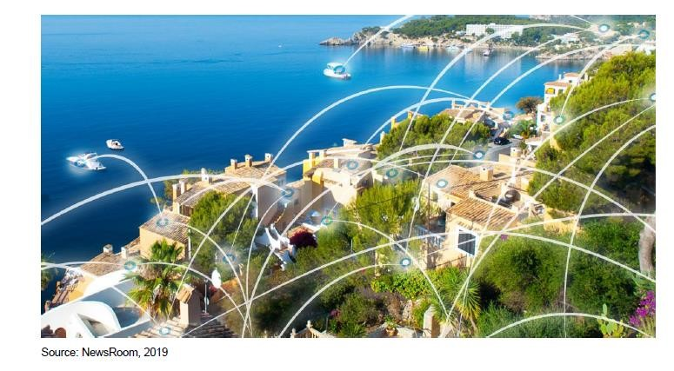

**Croatia’s Islands: Making the Most of Their Territorial Capital**

**Through Smart**

key areas of intervention or KAI

The thematic coverage of smart islands encompasses a wide range of development sectors

1. smart governance and smart resource management
2. smart economy
3. smart mobility
4. smart environment
5. smart living and safe islands

**Based on the conducted analysis, the key areas of intervention for “smart islands” are identified below:**

# Smart governance and smart resource management

1. e-public administration
2. ICT infrastructure
3. communication platforms for dialogue with citizens, and the civil and private sectors
4. smart planning of island development
5. encouraging social innovations
6. transparency of public data and information
7. integrated management systems for islands’ infrastructure and natural resources

**Based on the conducted analysis, the key areas of intervention for “smart islands” are identified below:**

# Smart economy

1. ecosystem for entrepreneurs
2. diversification of island economies
3. sustainable tourism development
4. territorial branding
5. development of creative and cultural industries and IT sector
6. expansion of opportunities for locally produced food
7. e-commerce
8. e-business and businesses networking
9. lifelong learning in line with the needs of the labour market and informatic literacy
10. development of skills related to smart specialization and entrepreneurship

**Based on the conducted analysis, the key areas of intervention for “smart islands” are identified below:**

# Smart mobility

1. infrastructure for clean island transport
2. alternative fuel infrastructure
3. walking, cycling and non-motorized transport infrastructure and services
4. digitalization of island transport systems
5. clean island transport vehicles
6. improving the mobility of the island population (not only tourists)
7. intermodal transport and better connectivity of islands and mainland

i) increasing the awareness of the local population and visitors about the need to preserve the environment and providing means for more rational use of resources

**Based on the conducted analysis, the key areas of intervention for “smart islands” are identified below:**

**4. Smart environment**

Croatia’s islands: Making the most of their territorial capital through smart solutions 26 a) renewable energy sources and promoting self-sustainable islands

1. smart energy and water distribution systems and smart drainage
2. smart public infrastructure
3. smart buildings, homes and districts
4. smart waste management
5. control and monitoring of air, soil and water quality, noise reduction
6. smart and environmental management of industrial sites
7. smart measures for adapting to climate change
8. increasing the awareness of the local population and visitors about the need to preserve the environment and providing means for more rational use of resources

**Based on the conducted analysis, the key areas of intervention for “smart islands” are identified below:**

**5. Smart living and safe islands**

1. high capacity broadband network
2. support to the development of e-citizens
3. digitalization in the field of health care (smart healthcare infrastructure)
4. and e-health services
5. smart educational infrastructure and development of educational platforms
6. social and inclusive infrastructure provision (including universal access for elderly and disabled)
7. protection, valorization and promotion of cultural heritage and cultural services
8. improvement in quality and security of public spaces
9. more effective development of a program to combat indigenous wildlife

# Palma de Mallorca in Spain

The municipality of **Palma de Mallorca is currently the second largest “Wi-Fi” city, after Miami (USA).** Wi-Fi Palma is a project run by the *Universitat de les Illes Balears* on big data and tourism. The project is being developed in cooperation with the Supercomputing Centre in Barcelona, the most powerful supercomputer in Spain. To increase its attractiveness as a tourism center, starting in 2014, Majorcan authorities began to provide free Wi-Fi access across the entire island starting in 2014 thus aiming to become an intelligent tourism destination.

# Europe

**On a global and European scale, there are good examples of smart island approaches worth learning from; some particularly relevant cases are presented below.** There are cases of islands implementing various smart solutions, which differ from smart city solutions in their scale and complexity, but which have the same aim of making a more efficient use of resources and achieving higher levels of environmental and social sustainability. **Samsoe island in Denmark**, for example, has a project known as *Fossil Free Island* where they are introducing a number of technologies such as biogas, smart energy systems, upgraded wind power feeding heat pumps, storage heat and electricity, energy savings, smart energy systems, and e-mobility (e-vehicles, ferry). Around 70-80 % of financing is obtained through public-private partnership and only 20% comes from funding or direct subsidy.

The **Island of Salina, often labelled as ‘the greenest of the Aeolian islands’**, has started its clean energy transition. The island has taken initiatives to promote eco-tourism and initiatives to reduce pol-lution and environmental degradation and is planning to implement energy efficiency and energy saving measures particularly in public lighting systems and the heating and cooling of its public buildings. Further, the municipalities aim to produce energy locally, capitalizing on the island’s abundant renew-able energy resources of electricity and heat, and to switch their public transport to electric minibuses powered by solar PV. Charging stations would be available for electric vehicles on the island as well. These initial plans and activities have been well received by residents, local tour operators and visitors.

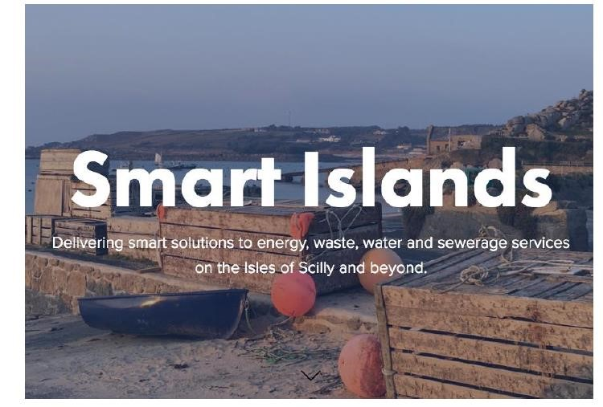

# The Smart Islands programme, the Isles of Scilly, United Kingdom

The Smart Islands programme in Scilly intends to deal with Scilly’s main infrastructure and utility issues through a sustainable and affordable approach, whilst providing a model for the community that can profit from a rapid transition from being carbon intensive to having a low carbon footprint. The main goals of the project are a 20% reduction in electricity bills by 2020 and 40% by 2025, to cover the isles’ energy demand with the renewable generation up to 40% by 2025, having 40% of vehicles be low carbon or electric by 2025 as well as increased offerings for internships, cultural exchange and STEM skill delivery for young people.

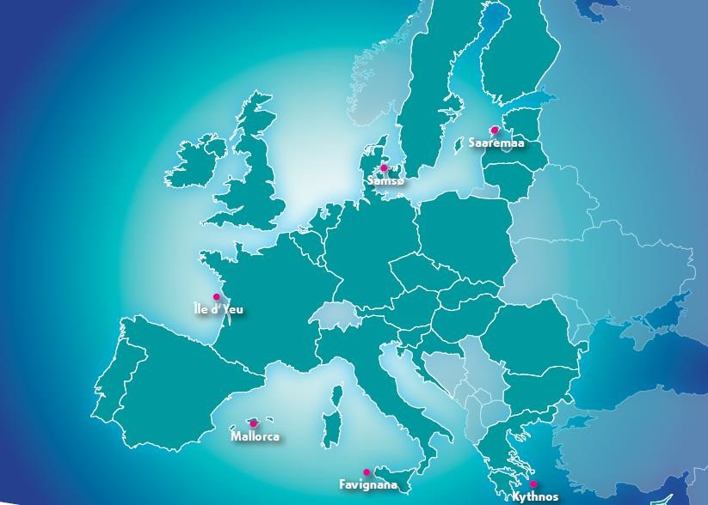

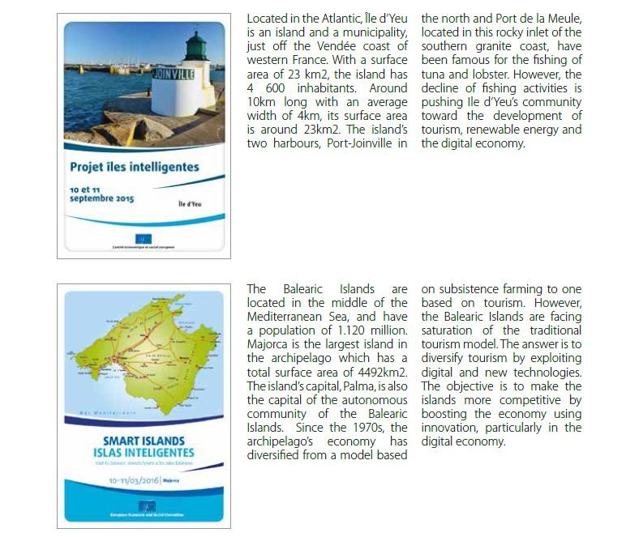

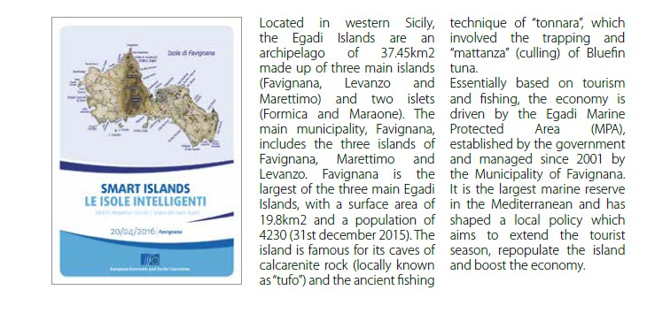

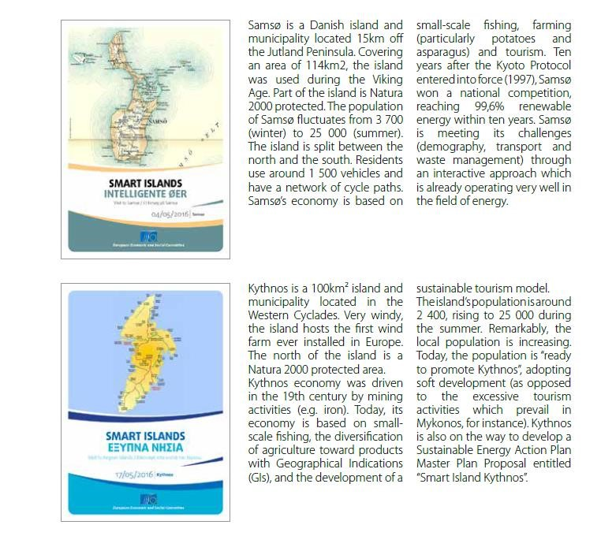

.

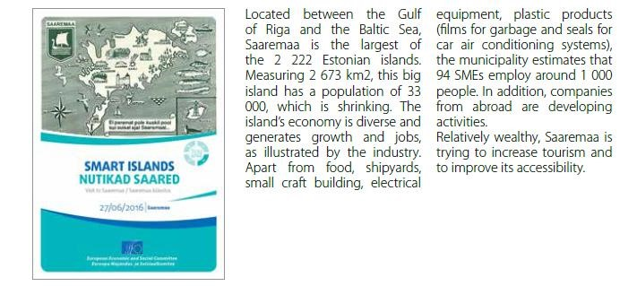

# Information and Communication Technologies (ICT)

* Big data and tourism

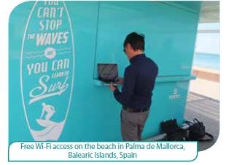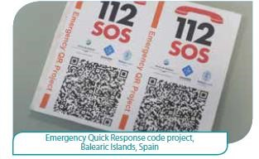

* Emergency Quick Response Code
* Internet broadband community
* Virtual care and services for the elderly population
* Smart small harbour services

# Innovation, including energy, transport and environment

* Offshore wind farm

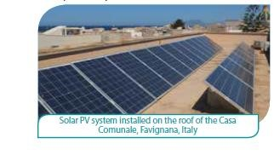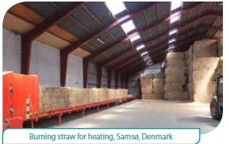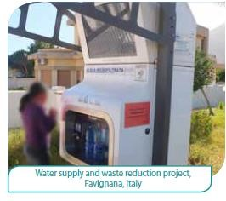

* Solar energy
* Energy efficiency and sustainable mobility
* Straw-fuelled heating systems
* Introduction of renewable sources of energy in the power
* Mix
* Public filtered water fountains to prevent plastic waste
* Marine Protected Area (MPA)

# Tourism development

* Redevelopment of the old processing factory

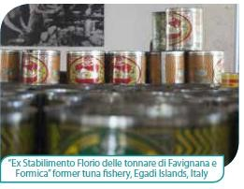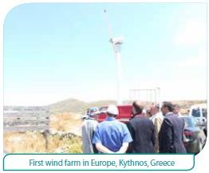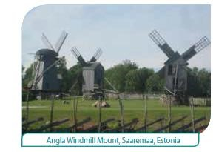

* Hiking and exploration trails
* Recreational fishing
* Ecotourism, preserving the heritage of renewable energy
* Preservation of the local architecture
* Cultural and heritage centre
* Geoparks

# Economic development other than energy or tourism

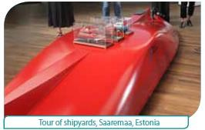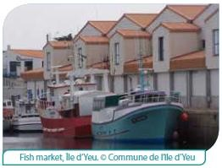

* Shipyards
* Small-craft competence center
* E-commerce
* Turning a declining market into a landing point
* Short supply chain
* Circular economy
* Labelling the island’s products

# Scientific initiatives to protect the marine environment

* 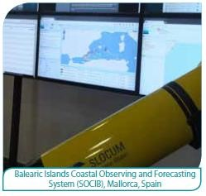Coastal observing and forecasting system
* Protection and study of marine meadows
* Rescue centre for Sea Turtles and Monk Seal Observatory

# Smart solutions in governance and social innovation

* Methods of cooperation
* SmileGov project
* The Pact of Islands
* Redeveloping the urban environment

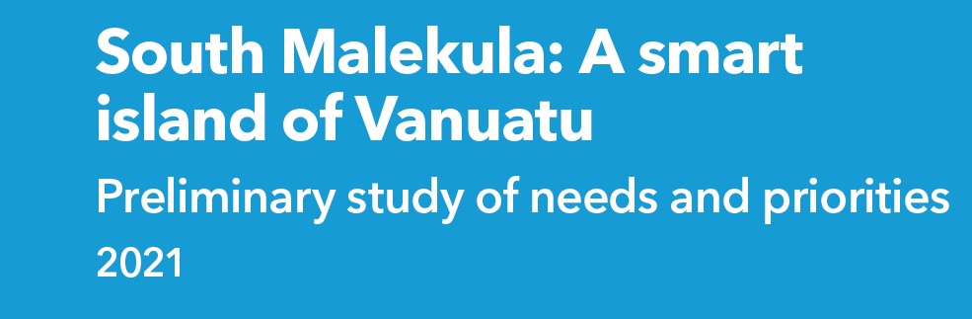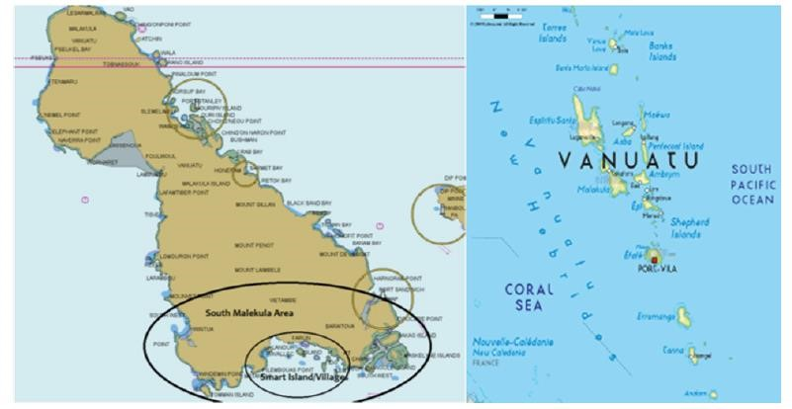

# Phased approach to the Smart Islands Vanuatu Programme

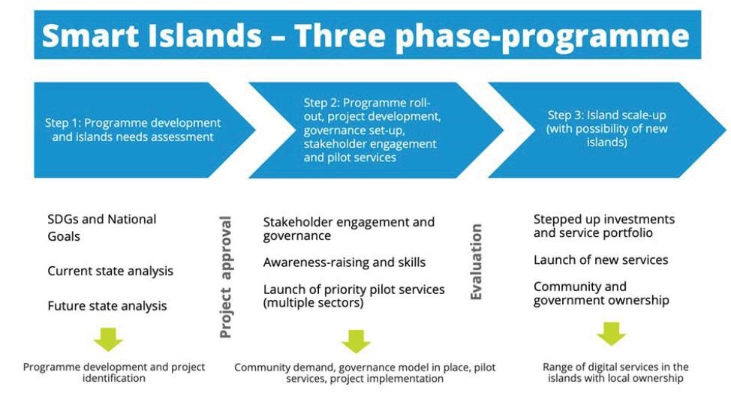

# Problem and solutions tree for Smart South Malekula

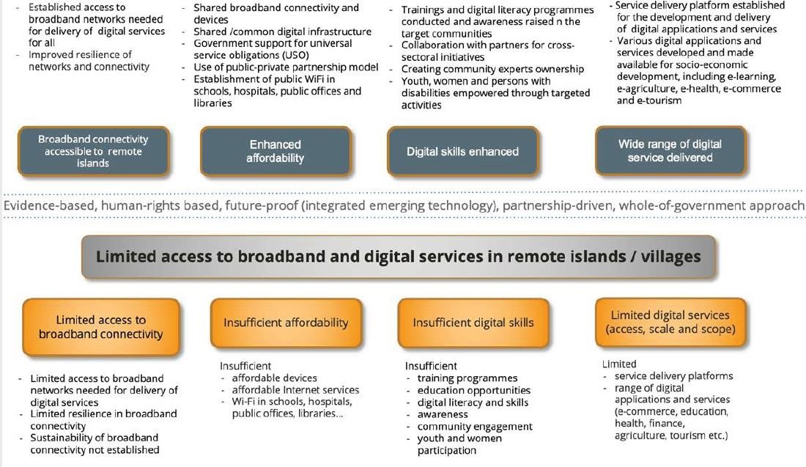

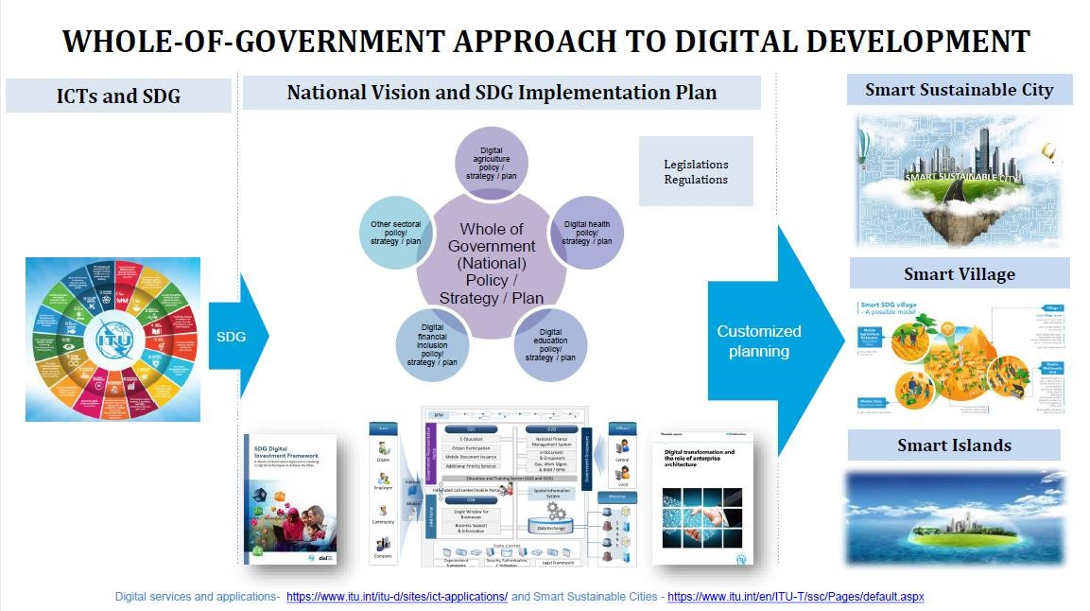

# Digitalization and Smart islands in the Kvarner archipelago

* Currently, in the European Union there are two major initiatives that address the issue of sustainable development of the islands. Top-down initiative coming from the Declaration on Clean energy for EU islands and bottom-up Smart Islands initiative.
* Both initiatives consider islands as living labs that can host innovative pilot projects and lead Europe's transition into a sustainable and low carbon environment. Following objectives of both initiatives, the Croatian government passes a law on islands that support the development of smart islands.

# Framework for Development of Smart Islands in Croatia

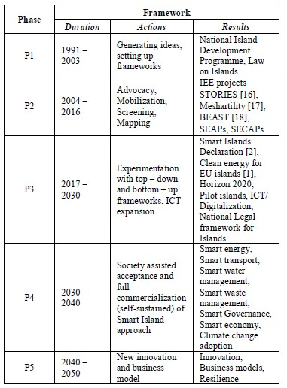

# Combining top-down with a bottom-up approach to develop Smart islands

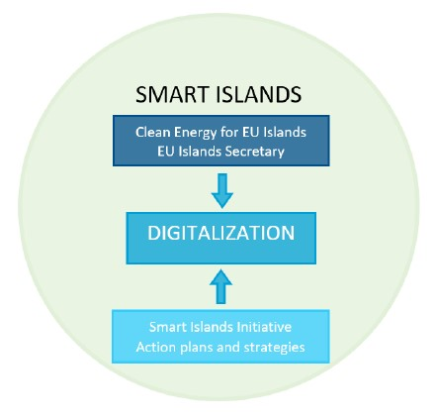

# LoRaWan connectivity and devices deployed for Smart Islands project

The network on the Cook Islands will run several smart island use cases including energy metering, water management, air quality streetlight operation and emergency notifications, such as tsunami sirens.

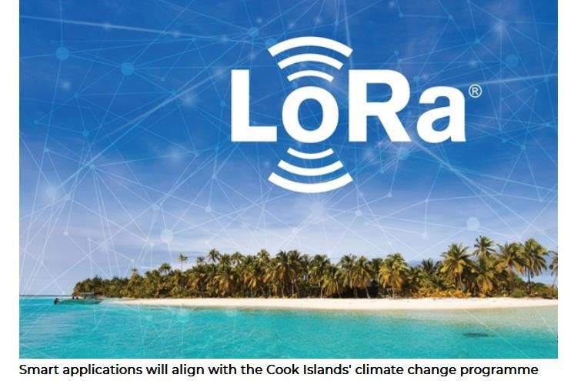

* A LoRaWAN network is being deployed on the Cook Islands in the South Pacific for a range of smart applications.
* It is a joint collaboration by semiconductors and advanced algorithms supplier Semtech and ICT and internet of things (ioT) solutions provider ICTnexus.
* As part of the ICTnexus Smart Islands project, an IoT platform will feature Semtech’s LoRadevices as well as a LoRaWAN network for the Island’s infrastructure.

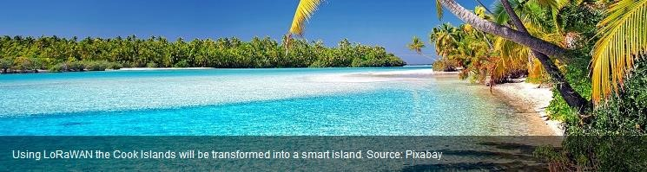

* The LoRaWAN will enable the islands to implement several smart island use cases including energy metering, water management, air quality and weather station monitoring, streetlight operation, asset tracking and emergency notifications, such as tsunami sirens.
* “Scalability was key in choosing the right technology to develop the Cook Islands into truly smart islands,” said Tai Kauraka Tangaroa, chief executive officer at ICTnexus. “As we start with Rarotonga for launch, building IoT infrastructure across 15 islands is no simple task, but the strong capabilities of Semtech’s LoRa devices and LoRaWAN standard provided an ease of deployment and scalability this comprehensive project requires to succeed.



**Caribbean Smart Islands – Digital Technology as a catalyst for Economic Growth and**

# Sustainability

## The Smart Islands Forum

* Caribbean-Central American Action in partnership with Mastercard and the Inter-American Bank will host this first “Caribbean Smart Islands” Forum in Washington DC on June 26th, 2018 to discuss how public and private entities can partner in the digital payments ecosystem to generate economic growth in the Caribbean.
* This event will bring together global industry leaders, government, international organizations and NGOs and associations.

**Theme 1: Smart Islands: Enabling the Ecosystem for digital payments**

**Theme 2: Tourism as a catalyst for growth and resilience in the Caribbean**

**Theme 3: Harnessing Trade for Growth: Enabling Caribbean SMEs to enter global commerce**

**One case of investment:**

# Hitachi confirms £10.8m Smart Islands investment

The project is co-financed by the European Regional Development Fund and will be conducted in collaboration with the Smart Islands Partnership and UK smart energy pioneers Moixa and PassivSystems. The initiative aims to “unlock and balance renewable energy generation, making 100 homes more energy efficient and supporting 200 businesses in the Isles of Scilly and in Cornwall, whilst reducing fuel poverty through the use of innovative technologies”. Hitachi also announced that it will develop and deploy an ‘innovative IoT (Internet of Things) platform’ on the islands through the Smart Islands Project, to demonstrate “how an individual community can build a replicable and scalable model to rapidly transition from being carbon intensive to a low carbon community”. They added: “Through the deployment of smart solutions across the islands’ infrastructure, the company will demonstrate the potential of the UK to take a lead role in this area “to inform the UK’s industrial strategy as well as to ensure a sustainable future for many regions of the UK and beyond".

# Smart Island' digital platform up and running in Mallorca

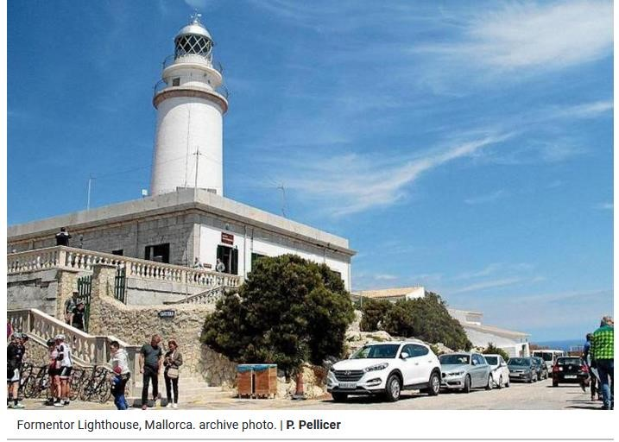

* The Consell de Mallorca’s **‘Smart Island’ digital platform** is already up and running, making it possible to consult a large amount of diata via a mobile phone, computer, or other public device such as information panels.
* The devices will be **installed at archaeological sites and lighthouses** to record visitor attendance.
* **Traffic 'Smart Island'** will monitor the roads, with 21 stations collecting data on vehicles,, making it possible to adjust mobility policies and message boards will warn drivers of traffic jams and other problems on the roads.
* **Meteorological stations** will monitor environmental conditions in certain areas of the island, which is very important for emergency management.

<https://www.majorcadailybulletin.com/news/local/2021/07/31/87555/mallorca-technology-smart-island-digital-platform.html>

* **Environmental and structural sensorial devices** have been installed at the Palau de la Diputación, the main headquarters of the Consell and at the Betlem de la Sang chapel, to control and prevent the deterioration of these facilities.
* Devices have also been placed on the **Misericòrdia building in Palma** to monitor energy efficiency and **at 180 bus stops** to advise passengers of waiting times, mobility alternatives and other issues.
* State-of-the-art hardware has been given to Firefighters and the Emergency Services.
* ‘Smart Island’ works via a data transmission network and the Government has poured **9 million euros** into the project.

<https://www.majorcadailybulletin.com/news/local/2021/07/31/87555/mallorca-technology-smart-island-digital-platform.html>

